STATISTICS

- Correlation Coefficient (Pearson’s r)

When we say there is a correlation between two variables, we are only saying there is a connection. We CANNOT conclude that one variable has caused the other. We can only say that they seem somehow related.

Perfect Correlation- r = 1.00

No Correlation- r = 0.00

POSITIVE CORRELATION (on a scatterplot)
* variables move in the same direction
As one variable increases, the other variable also increases

. . .
. . .
. . .
. . .
. . . .
. . . .
. . . .
. .
.

Variable A
Variable B

NEGATIVE CORRELATION (on a scatterplot)
*variables move in OPPOSITE directions
As one variable increases, the other variable decreases

. . .
. . . .
. . . .
. . .
. . .
. . .
. . .
. . .
. . .

Variable A

Descriptive Statistics- summarize or describe information about a group

- Normal Distribution (the bell curve)-

- Skewed Distributions-

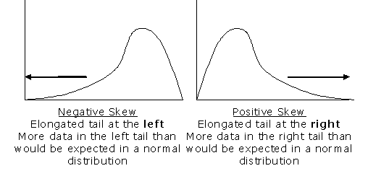

- Measures of Central Tendency (middle)

*Mean- Average score
Mode- Most prevalent score
Median- Score in the middle

- Standard Deviation- measures how spread out scores are in relation to the mean

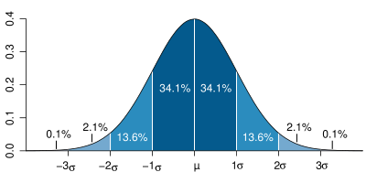

- Percentiles- percentile scores indicates the percentage of all scores that lie below the given score. For example, if on a test you scored at the 80th percentile, that means that 80% of the other people scored below you. Or put another way, you scored better than 80% of the population.

Variable B
Inferential Statistics- analyze data to determine whether they are the result of mere chance, or are actually the result of an experiment (manipulation by the researchers)

Statistical Significance- We say that something is “statistically significant” if we can say we are at least 95% sure that the differences between groups in an experiment (experimental group and the control group) are not due to chance, but are the result of the manipulation of the INDEPENDENT VARIABLE.

Nominal Data- This is used to group information into categories.
Ex: Which TV channels do you watch most? Channels 2 and 4.
We can’t average these two numbers and say that the most commonly watched channel is channel 3! We can only categorize the responses.

Ordinal Data (like order of importance)- Ordinal data is used when we want to rank information.
Ex: If you were asked to list ten people you admire, you would give the most admired person a rank of “1”. The next most admired person the rank of “2”, and so on.
***Notice how this is different than Nominal data. Channel 2 is different than channel 4, but not necessarily more or less of any specific characteristic.

Interval Data- Equal units of response time, where some part of the response (even if unknown) can be said to be constant.
Ex: response time = decision time + button-press time
Even if we don’t know how long it takes to press the button, we assume that the time it takes to press the button is constant.

Ratio Data- Celsius to Fahrenheit
2:1

